Assignment for CRM
1. Customer Segmentation &amp; Insights • Pull a list of customers with no purchases or interactions in the past 90 days. • Segment the list based on: o Product categories previously purchased o Average order value o Customer location (if relevant for shipping or promotions) o Engagement with past marketing emails
Ans…
Here I am using Salesforce Marketing Cloud (SFMC)
for doing segmentation Task
I am using these Below module
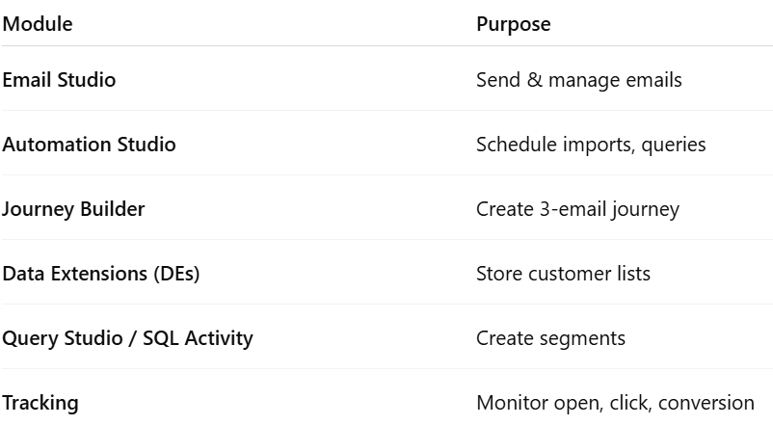

Step -1 Suppose --Let’s assume my e-commerce brand sells fashion and lifestyle products (clothing, accessories, and footwear).
First I am login my CRM tool with my user id and pass
after login we can see this below page
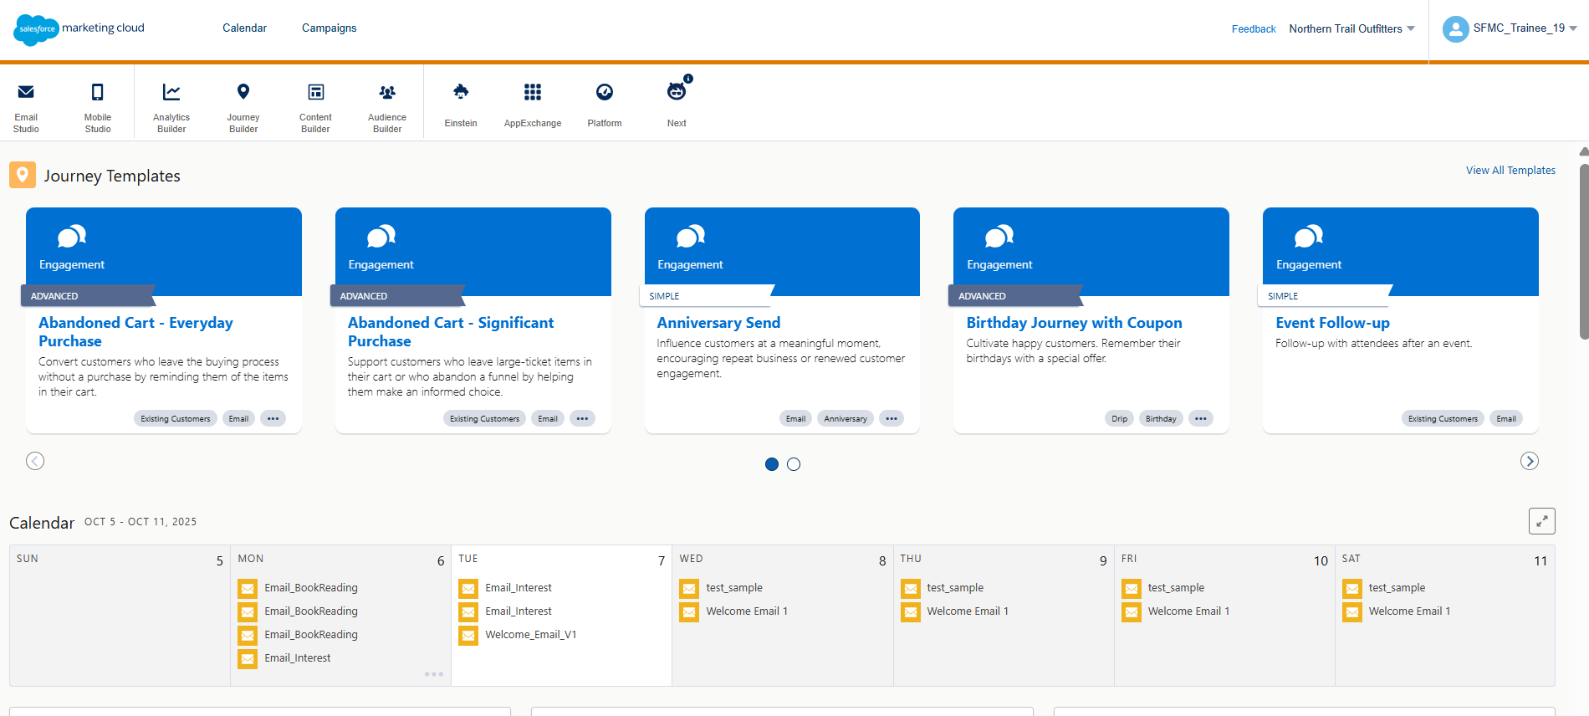
After that we will click on Email Studio and then Email
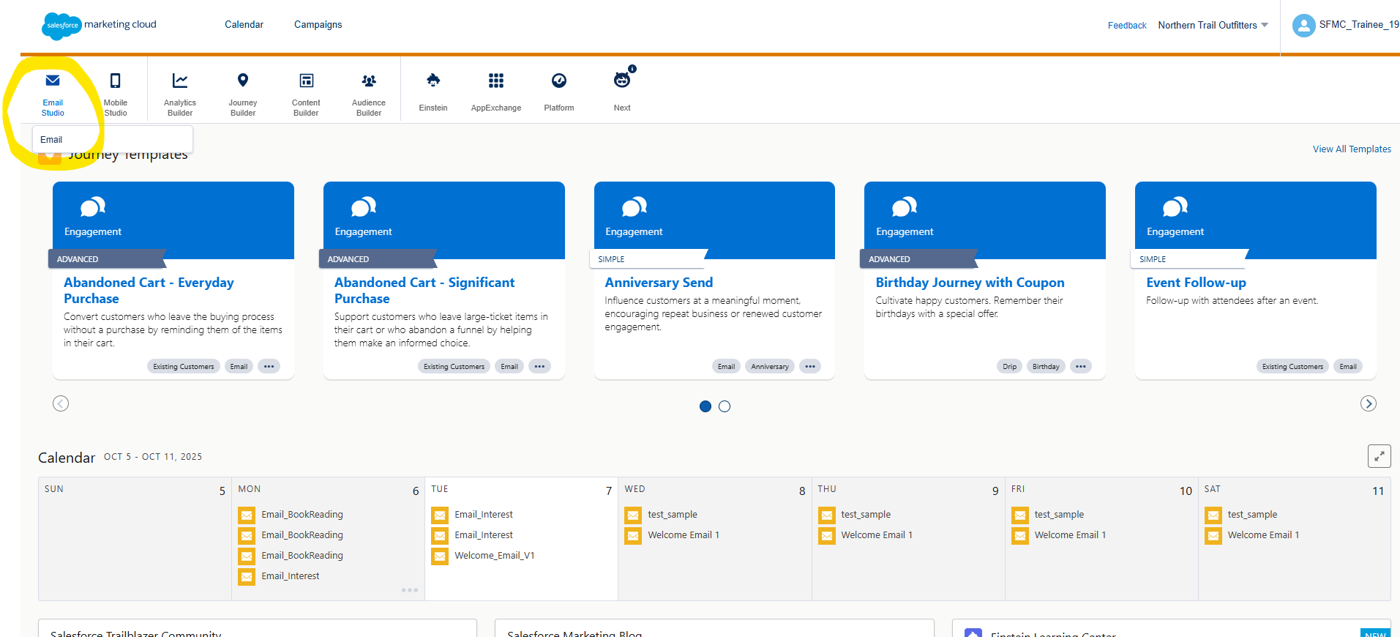

Then We will define target Audience
Inactive customers = Customers with Last Purchase Date > 90 days ago
We will click on subscriber then data extension
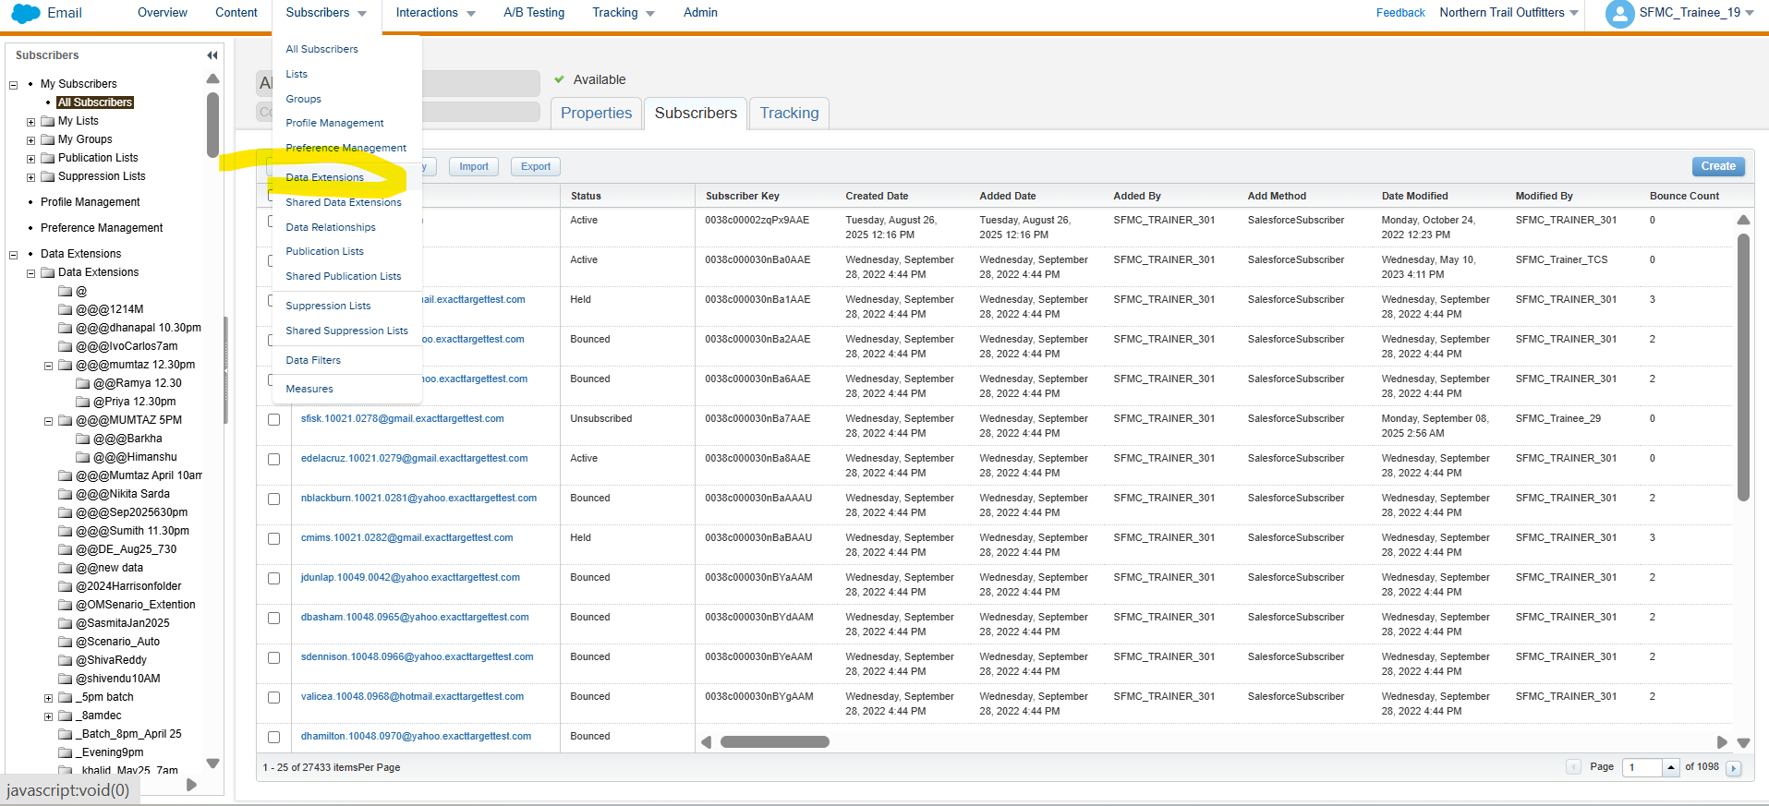

Click on create
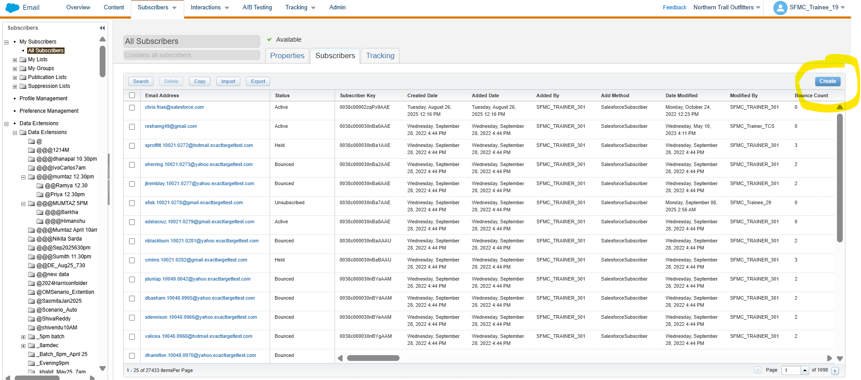

Go to standard
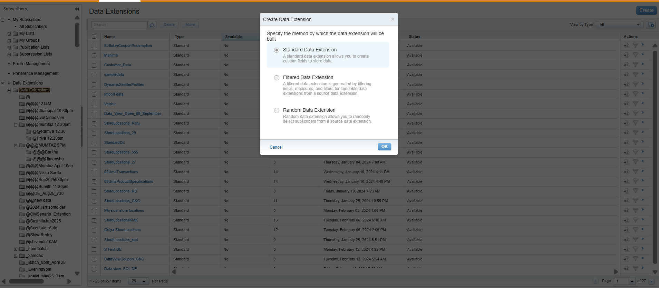

Provide name as per my segmentation
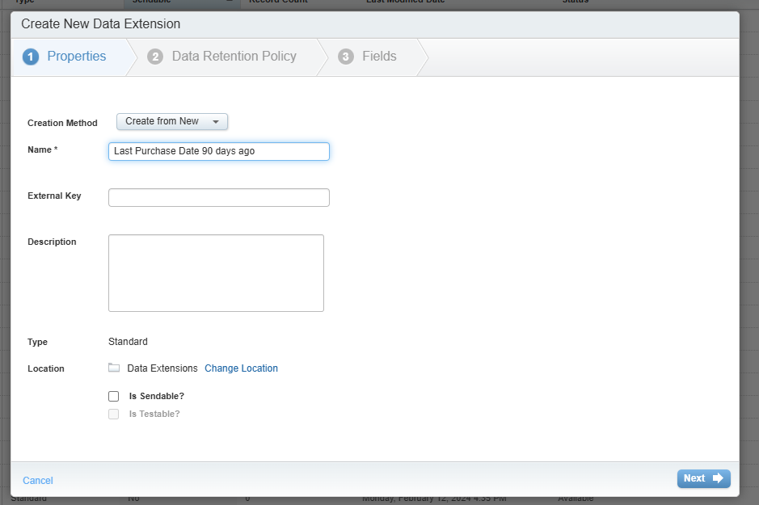
Then I will create all fields
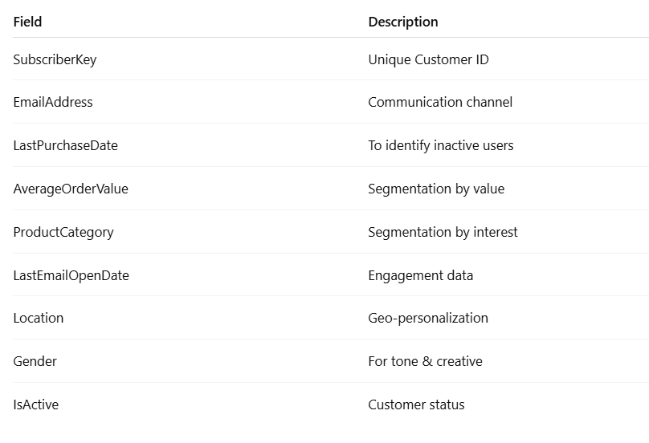
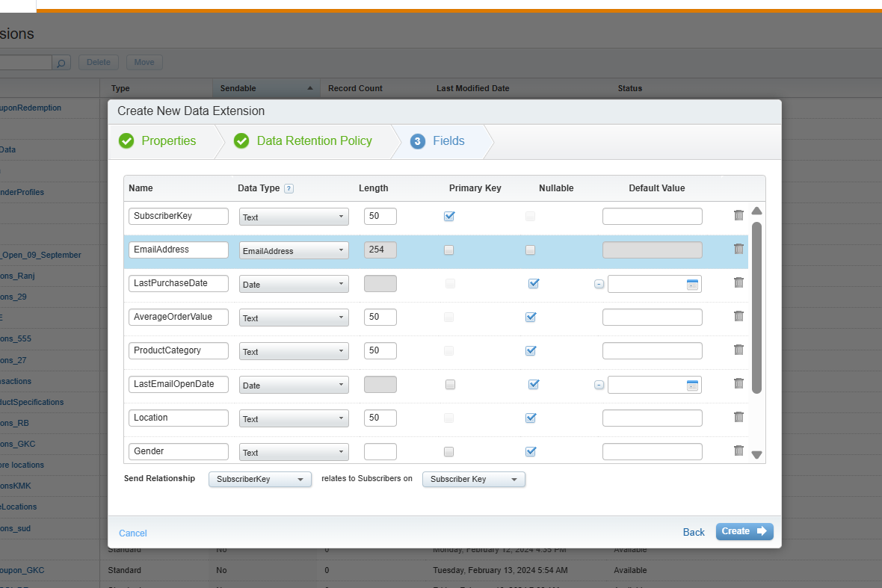
Here is the sample data
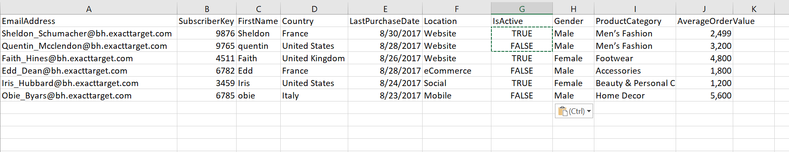

Here’s all data are uploaded
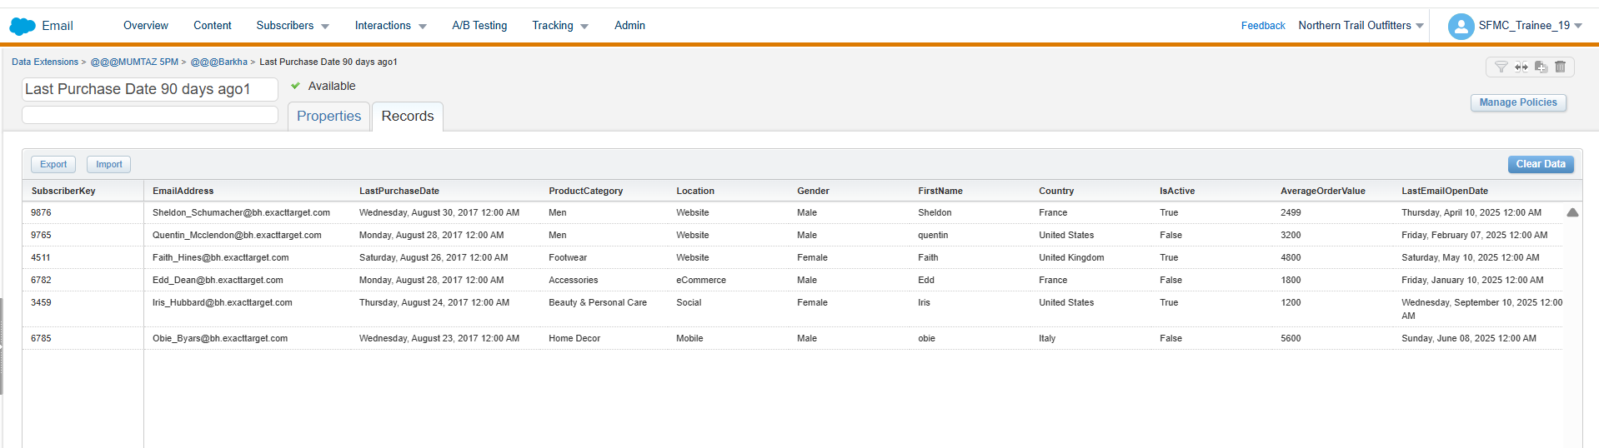

We can make segmentation through SQL query or we can make segmentation and import that data on CRM as depend on you. create sub-segments using Query Activity or Filtered DEs
SQL Query below
SELECT
c.SubscriberKey,
c.EmailAddress,
c.FirstName,
c.LastName,
c.Location,
c.AverageOrderValue,
c.LastPurchaseDate
FROM
Customer_Master c
WHERE
c.LastPurchaseDate <= DATEADD(day, -90, GETDATE())
AND c.IsActive = 1

We have to create Data Extensions for each segment:
- Inactive_90D_Beauty
- Inactive_90D_HighAOV
- Inactive_90D_Delhi

Filter Activity (No SQL)
If SQL not allowed → use Data Filters in Email Studio → Subscribers → Data Extensions → Create Filtered DE
Filter Logic:
- LastPurchaseDate is before “90 days ago”
- IsActive equals True
